Alli Miller – CIS 1020 – 126 - Library#1
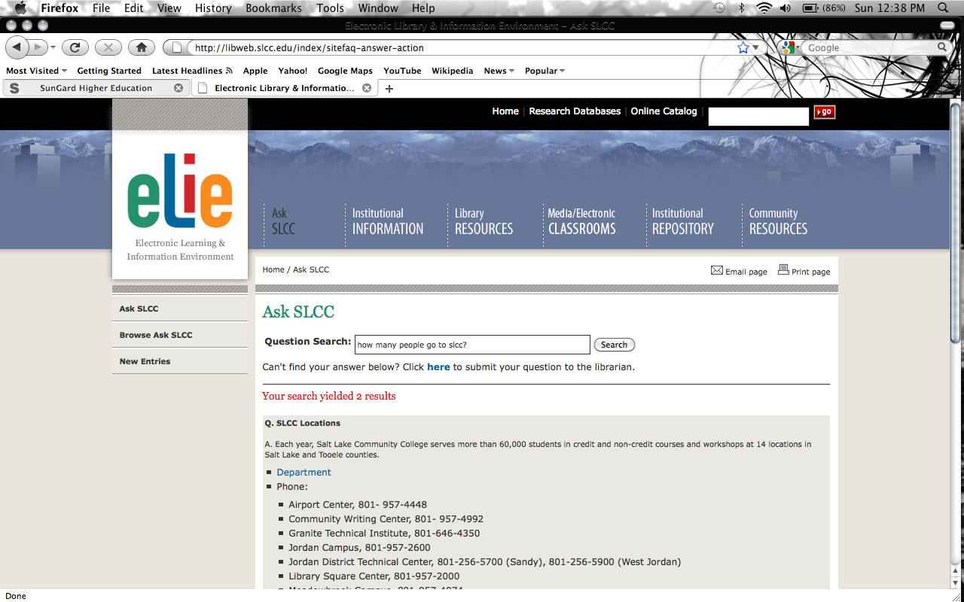

Assignment#2
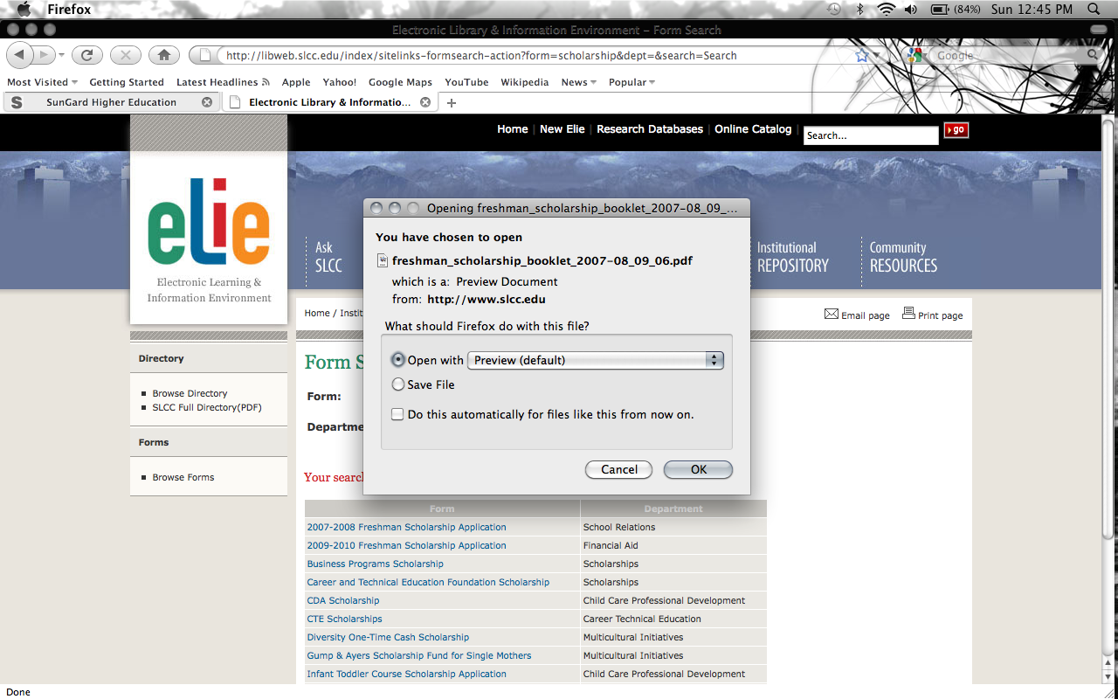

Assignment#3
The Education page is no longer there. When I click on the link it just says the page could not be found.

Assignment#4
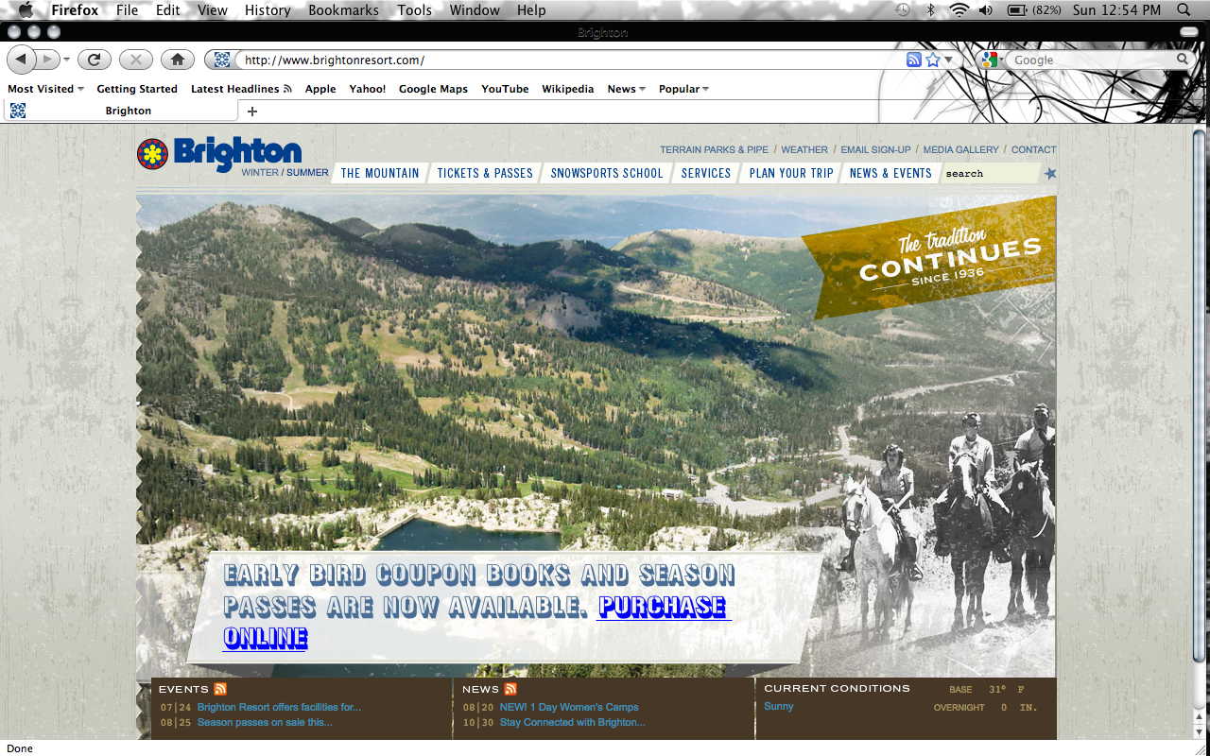

Assignment#5
Media/Electronic Classrooms – This page is about the Electronic classes you can take at all the different campuses. Some of the classes are Video Resources, Media Equipment, Electronic Classrooms, and many more.

